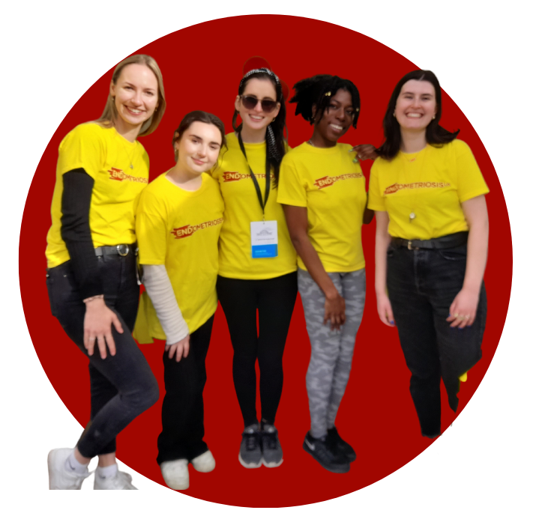
Role Outline – Support Group Facilitator
We are looking for self-motivated and compassionate individuals to help facilitate our support groups and make a difference to the lives of the 1.5 million in the UK who suffer from endometriosis.

Support Groups offer those with endometriosis a chance to share their feelings and experiences in a safe and welcoming environment. Support Group Facilitators listen, provide emotional support and share approved endometriosis information.

No special qualifications are needed for this role, but being able to devote time to setting up and maintaining a group is essential.
What will you do?
- Provide a safe and supportive environment for those with endometriosis or those connected them.
- Organise meetings and activities.
- Recruit and maintain membership of the group.
- Secure guest speakers when requested by the group.
- Signpost to further information and approved organisations when needed.
- Manage the support group’s Facebook page.
- Raise awareness of endometriosis at a local level and represent Endometriosis UK’s at a local level.
- Share approved information about the condition.
- Participate in national activities at a local level, e.g. Endometriosis Action Month
- Update the Support Network team and Head Office of activities.
- Report back on support group activity
- Act in line with our Volunteer policies and Code of Conduct
Skills and experience needed
- Personal experience of endometriosis.
- Excellent communication and interpersonal skills.
- Ability to speak authoritatively about endometriosis without embarrassment and explain a complex disease in simple terms
- Ability to maintain professional boundaries
- A well-developed ‘listening ear’
- Ability to empathise with people and not to over-sympathise
- Provide approved information and not advice.
- Awareness of the importance of confidentiality
- Ability to manage your own experiences and support needs
- Ability to communicate with people from different backgrounds in a non-judgmental way
- Strong leadership skills and be self-motivated.
- Ability to organise meetings, publicity campaigns
- Willing to take enquiries referred from other support services and Head Office.

“My Endometriosis UK Support Group is my lifeline.”
Endometriosis UK Support Group Member
Time and Location
You will need to be able to commit to this role for a minimum of at least 6 months.
You will need to set aside time to plan, organise and deliver at least 6 support group meetings a year.
You will need to set aside time for weekly check ins on the Facebook group.
Support group meetings will be carried out both in-person and online.

Training, Support and Expenses You will be required to attend in-person induction training and have access to ongoing online training to support you in your role.
There will be ongoing support and supervision from Endometriosis UK’s Support Network team. All reasonable expenses are paid for by Endometriosis UK.

How to apply If you are interested in this role, please complete and submit <<application form>> to volunteer@endometriosis-uk.org
Successful candidates are invited to attend an online interview.
You must provide two-character references and be willing to undertake a basic Disclosure and Barring Service (DBS) check.
Suitable candidates are required to attend induction training, either in-person or online before starting in post.

We encourage interest and applications from those who identify as LGBTQIA+, as a person of colour, experiencing childlessness by choice and not by choice. We want to increase representation of these communities amongst our volunteer and service users.

