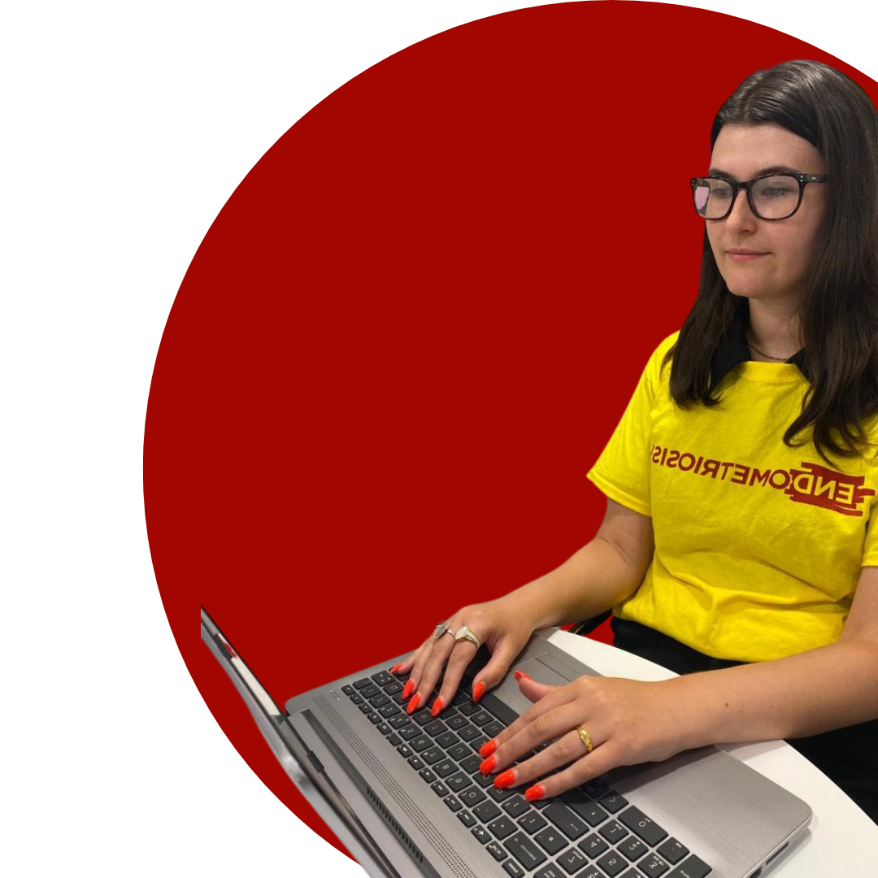
Role Outline – Health Unlocked Moderator
We are looking for self-motivated and compassionate individuals to help moderate the Health Unlocked forum and make a difference to the lives of the 1.5 million in the UK who suffer from endometriosis.

Health Unlocked provides information, support, a sense of belonging and community to those with endometriosis. Moderators can help others by using their own knowledge and occasionally their own experience of endometriosis.

No qualifications needed for this role, but access to a computer/smart phone/tablet and the internet is essential.
What will you do?
- Provide a safe and supportive environment for those with endometriosis or those connected them.
- Ensure the forum is a relevant
- Take part in discussions, respond to posts by providing relevant, unbiased and accurate information
- Report posts or private messages that are offensive or violate the forums code of conduct.
- Mediate and resolve inflammatory discussions that may arise between users.
- Remove SPAM posts.
- Ensure users are aware of the importance of their own privacy and safety.
- Act in line with our Volunteer policies and Code of Conduct
Skills and experience needed
- Have personal experience of endometriosis.
- Excellent communication and interpersonal skills
- Ability to speak authoritatively about endometriosis without embarrassment and explain a complex disease in simple terms
- Ability to maintain professional boundaries.
- A well-developed ‘listening ear’
- Ability to empathise with people and not to over-sympathise
- Ability to provide approved information and not advice.
- Awareness of the importance of confidentiality
- Ability to manage your own experiences and support needs
- Ability to communicate with people from different backgrounds in a non-judgmental way.
- Willing to take enquiries referred from other support services and Head Office.

“What I really love about my role is when I see those taking control and really voicing their experience”
– Endometriosis UK Volunteer

Time and Location
You will need to be able to commit to this role for a minimum of at least 6 months.
Commit to a minimum of a 2 to 3 hour shift per week, we will agree a routine time and day.
This is a remote working role, based in the UK.

Training, Support and Expenses You will be required to attend in-person induction training and have access to ongoing online training to support you in your role.
There will be ongoing support and supervision from Endometriosis UK’s Support Network team. All reasonable expenses are paid for by Endometriosis UK.

How to apply If you are interested in this role, please complete and submit <<application form>> to volunteer@endometriosis-uk.org
Successful candidates are invited to attend an online interview.
You must provide two-character references and be willing to undertake a basic Disclosure and Barring Service (DBS) check.
Suitable candidates are required to attend induction training, either in-person or online before starting in post.

We encourage interest and applications from those who identify as LGBTQIA+, as a person of colour, experiencing childlessness by choice and not by choice. We want to increase representation of these communities amongst our volunteer and service users.

